View()

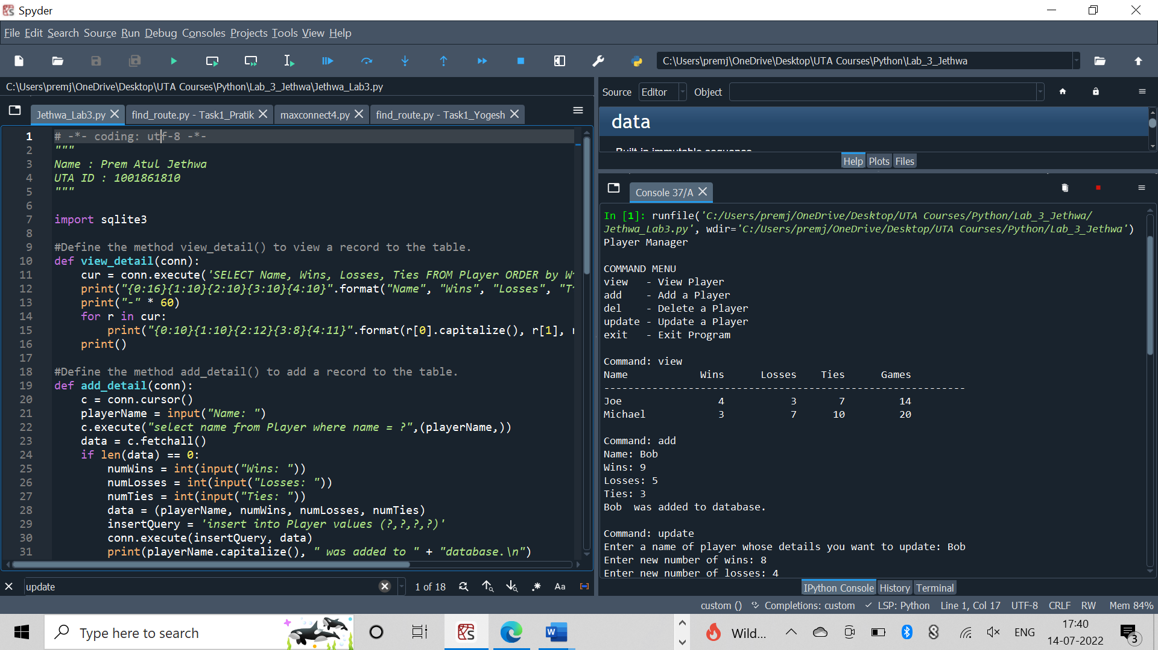

Add()

Update()

Delete()

